Active Directory Lab 03
Delegating Password Reset Permissions in Active Directory
Objective
The objective of this lab was to understand the concept of delegation in Active Directory by assigning limited administrative privileges to a security group. The lab demonstrated how to delegate password reset permissions to the IT_Team security group, verify the delegated permissions, test password reset functionality using the graphical interface, and validate the principle of Least Privilege by confirming that unauthorized administrative actions were restricted.

Lab Environment
Component | Details
Operating System | Windows Server (Domain Controller)
Client Machine | Windows 11
Virtualization | VMware Workstation / VirtualBox
Domain | mydomain.com
Tool Used | Active Directory Users and Computers (ADUC)

Step 1: Delegating Password Reset Permissions
The Active Directory Users and Computers (ADUC) console was opened on the Domain Controller, and the Delegate Control Wizard was launched for the _EMPLOYEES Organizational Unit. The IT_Team security group was selected as the delegated group.
A custom delegation task was configured for User objects, and the following permissions were assigned:
- Reset Password
- Read User Information
- Write User Information
These permissions allowed members of the IT_Team security group to perform password resets and update user information without granting them full administrative privileges.

Result
Password reset permissions were successfully delegated to the IT_Team security group for all user accounts within the _EMPLOYEES Organizational Unit.
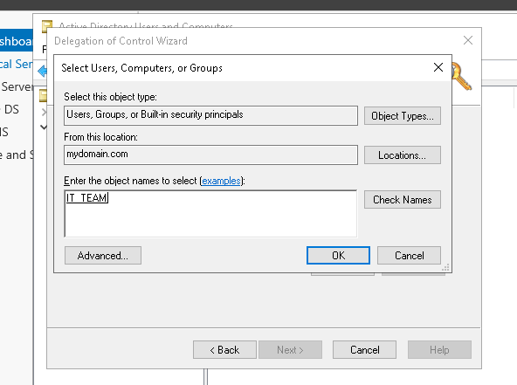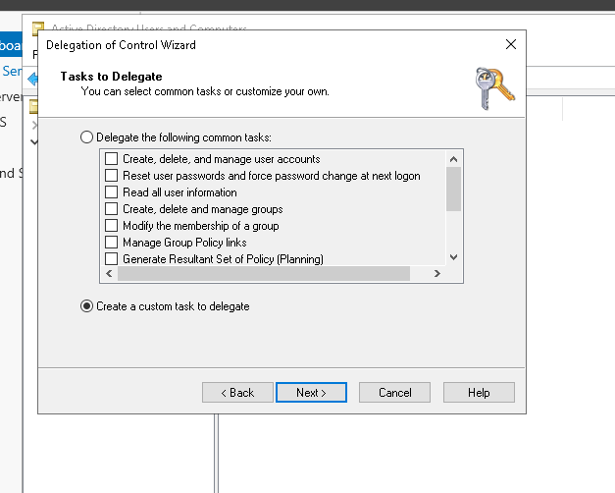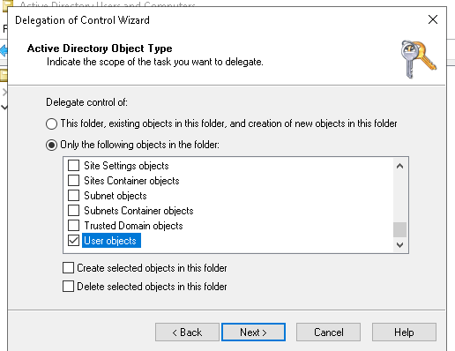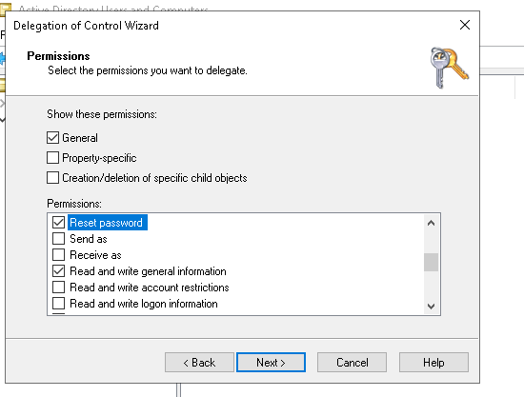

Step 2: Verifying Delegation Settings
After completing the delegation process, the security settings of the _EMPLOYEES Organizational Unit were reviewed through the Security tab in the OU properties. The delegated IT_Team group appeared in the access control list with the configured permissions.
This verification confirmed that the delegation had been applied successfully and that the required permissions were available to members of the security group.
Result
The delegated permissions were successfully verified in the Organizational Unit security settings.
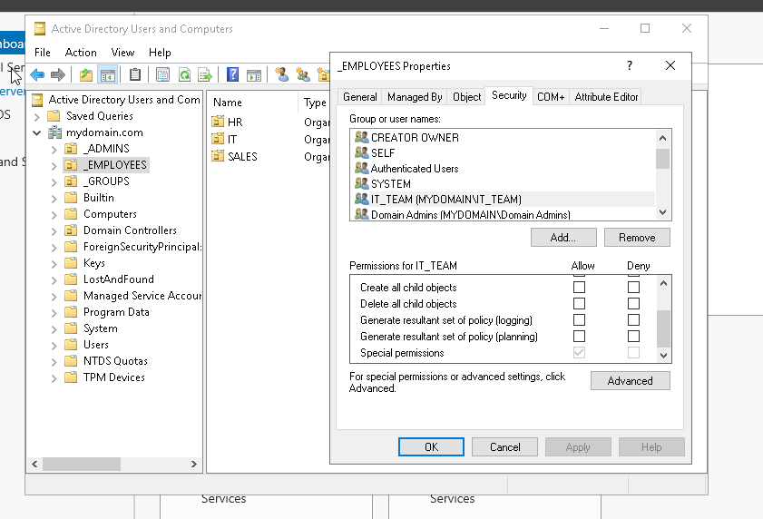
Step 3: Testing Password Reset Delegation
To validate the delegated permissions, the Windows 11 client machine was used to log in with the john.doe domain account, which is a member of the IT_Team security group.
Using the Active Directory Users and Computers (ADUC) graphical interface, the password of jane.smith was reset to NewPass123! through the Reset Password option. After the password was updated, the user account jane.smith was used to log in to the client machine with the new password.
The successful login confirmed that the delegated password reset operation had been completed successfully.

Result
The delegated user successfully reset the password of another domain user through the ADUC graphical interface, and the updated credentials were verified by logging in with the new password.
Screenshot 3: Password Reset Using ADUC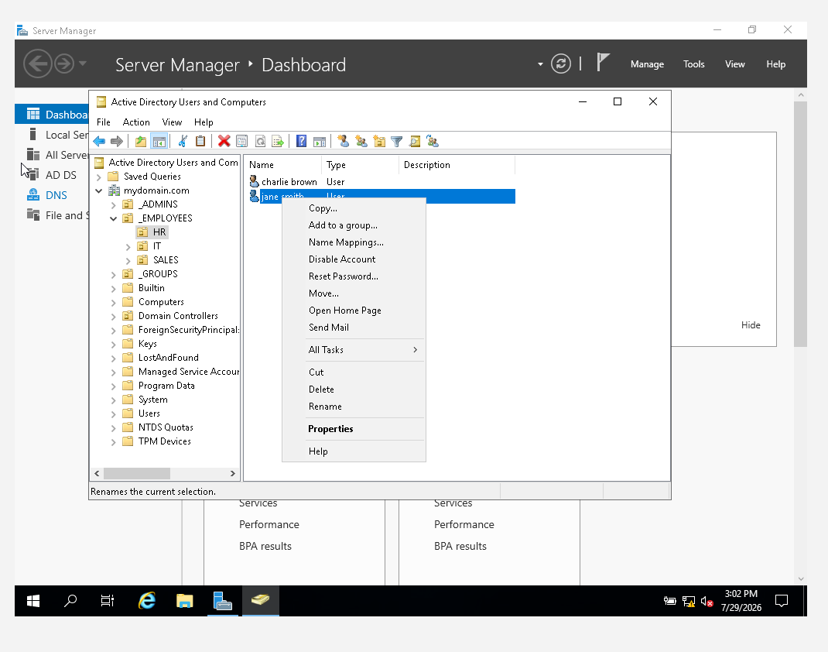
Screenshot 4: Successful Login Using the New Password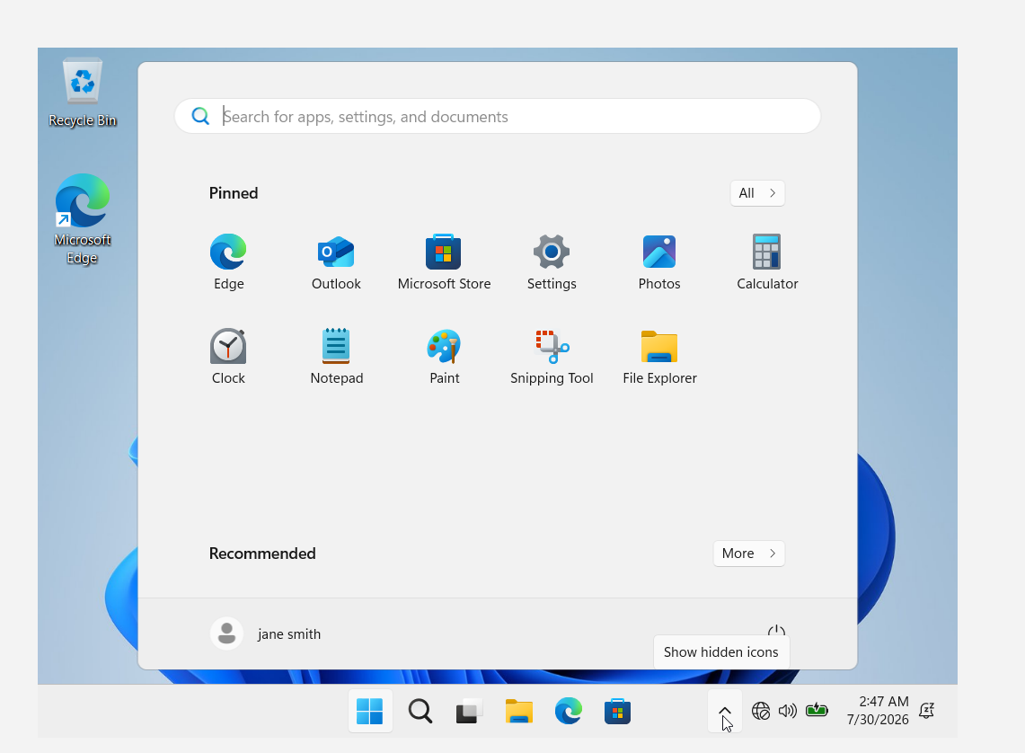

Step 4: Verifying Delegation Limitations
To verify that delegation followed the Least Privilege principle, an attempt was made to delete an existing user account while logged in as john.doe. The operation failed because the delegated permissions only allowed password resets and limited user management operations.
This confirmed that administrative privileges were restricted according to the delegated permissions and that users could not perform unauthorized actions.
Result
The delete operation was denied, confirming that only the delegated permissions were available to the IT_Team security group.

Step 5: Testing Delegation Scope
To verify the scope of the delegated permissions, another user account located in the Sales Organizational Unit (bob.wilson) was selected. Using the delegated account, the password was successfully reset through the Reset Password option in Active Directory Users and Computers.
This demonstrated that the delegation applied to the parent _EMPLOYEES Organizational Unit, allowing delegated permissions to be inherited by all child Organizational Units, including IT, HR, and Sales.
Result
The password reset operation was successfully completed for a user located in a different departmental Organizational Unit, confirming that delegation was inherited across all child OUs.

Conclusion
This lab demonstrated the implementation of delegation in Active Directory by assigning limited administrative privileges to the IT_Team security group. Password reset permissions were successfully delegated and verified using the Active Directory Users and Computers console. Members of the delegated group were able to reset passwords for users across the _EMPLOYEES Organizational Unit while remaining restricted from performing higher-privileged administrative actions such as deleting user accounts. The lab highlighted the practical application of the Least Privilege principle and demonstrated how delegation enables secure distribution of administrative responsibilities in enterprise Active Directory environments.

